Weekly Summary Memo for: Team 09 – Wireless Car

To: Prof. Yoder Date: 23-10-15

Specific accomplishments for the week

● Work structure has been Made Clear.

● Parts and other components of the car have been listed out.
● Any other specific modification If needed also been decided.

Missed Objectives

● Cost estimation

Specific Goals for Next Week (Assigned to individuals with due dates)

● Working condition of the Electric components. (By Srinath 26th Oct)

● Internal Design of the car and also some circuits (By Srinath 27th Oct)

● Flow chat of the work structure and also the line follower method (By Srinath 27th Oct)

● buying the car and dismantling it for further development of our project (By Sanjeev 28th Oct)

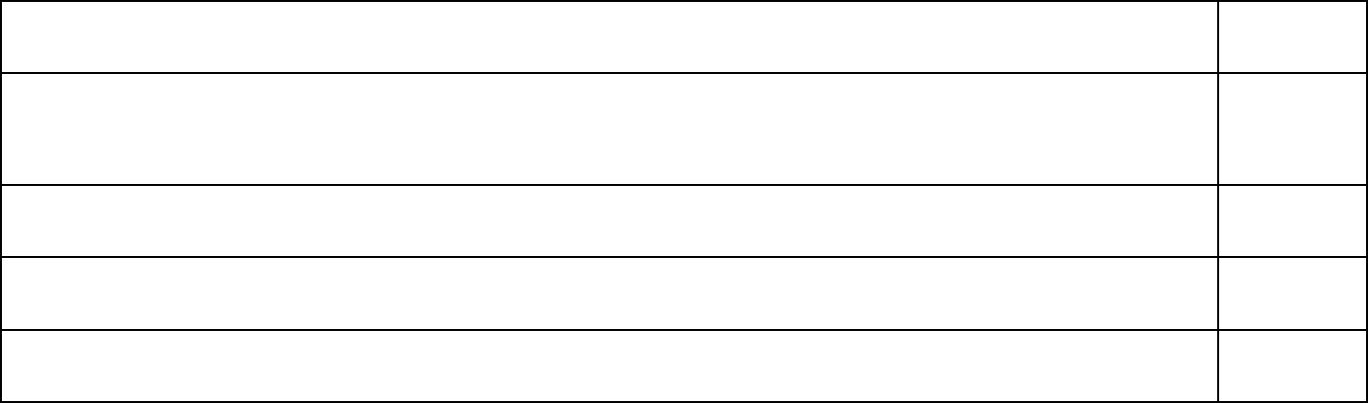
Member actions from past week: | Hours

Name: M.R.Srinath 06

Name: Sanjeev Raydu 02

Name​:

Name​:

Feedback:
There is a change in project idea as we were working on the email system and electronic dice now we shifted our idea to wireless car.
In this project we try to implement it through some line follower.
Some other modifications can also be done by using some sensors by this we can control it by the motion of our hand.

